Task on VPC Transit Gateway & VPC Endpoint

1. Create one VPC, with 1 public subnet and 1 private subnet.

PURPOSE: The purpose of creating one VPC with 1 public subnet and 1 private subnet is to separate resources that need internet access from those that should remain protected.

OBJECTIVE: To create a secure and isolated network environment in AWS by using a VPC with one public subnet and one private subnet, allowing internet-facing resources to be separated from internal resources.

OUTCOME: A secure AWS network infrastructure is established with a VPC containing one public subnet and one private subnet, enabling controlled internet access for public resources while protecting private resources from direct external access.

STEP BY STEP IMPLEMENTATION:
- First of all, sign into the AWS management console.
- Then navigate to the VPC Dashboard.
- Then edit the vpc details in the page and click on create VPC.
- It will create a new VPC.
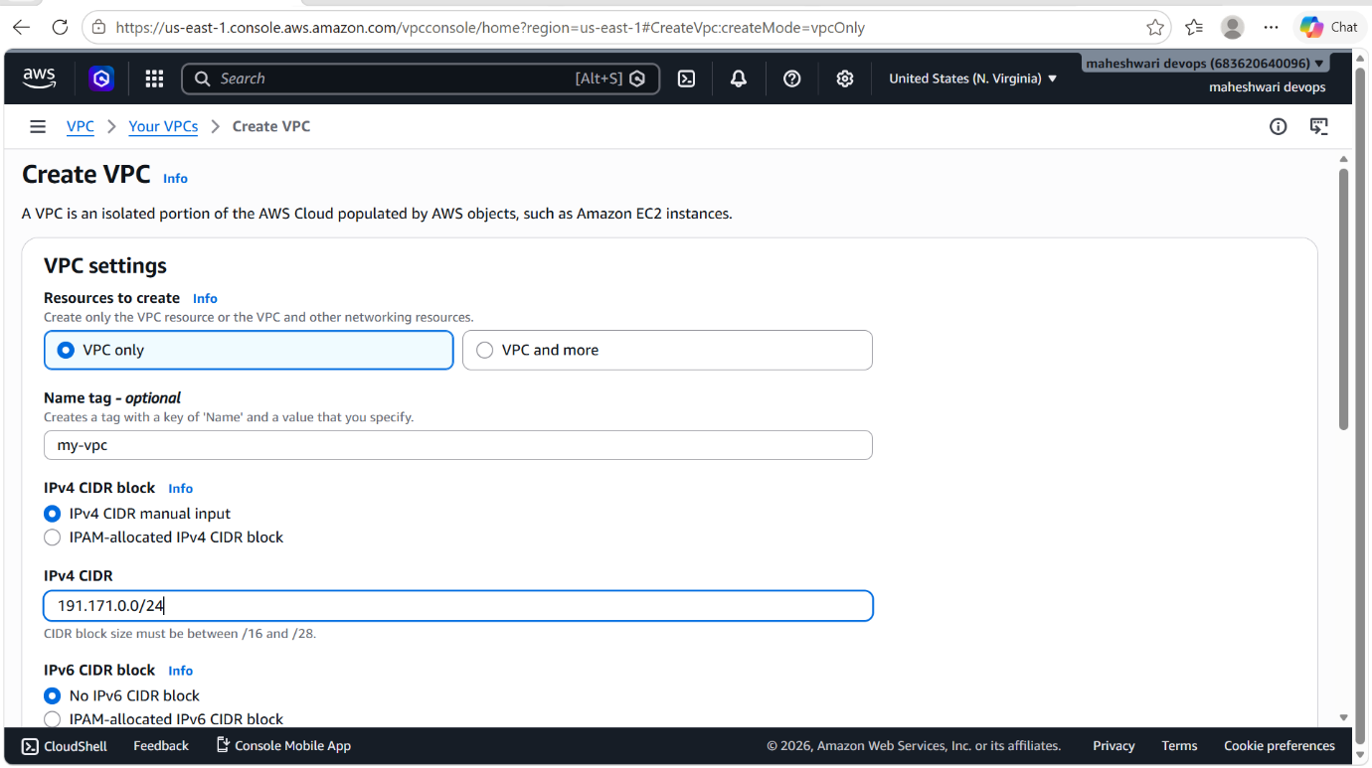

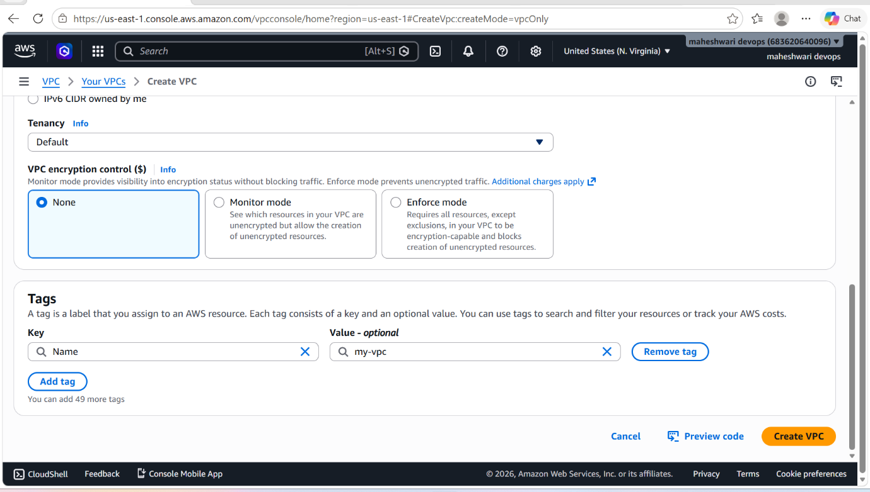

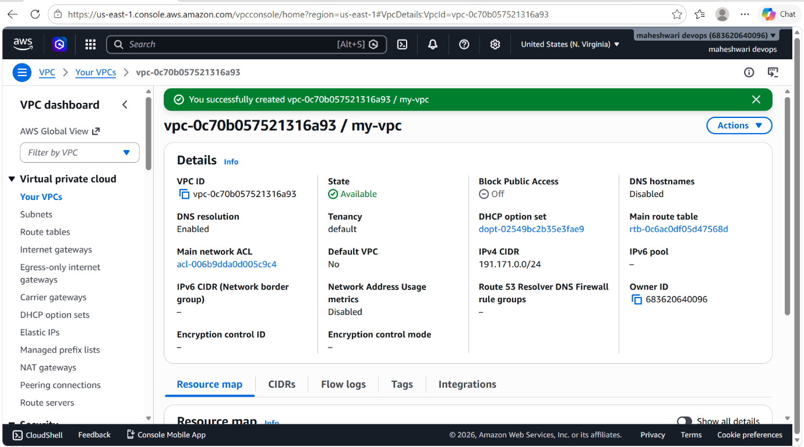

- In the navigation pane, go to subnets
- Then click on new subnet to create a public subnet.
- Fill the details in the subnet page
- Then click on create subnet with the name pub-subnet.

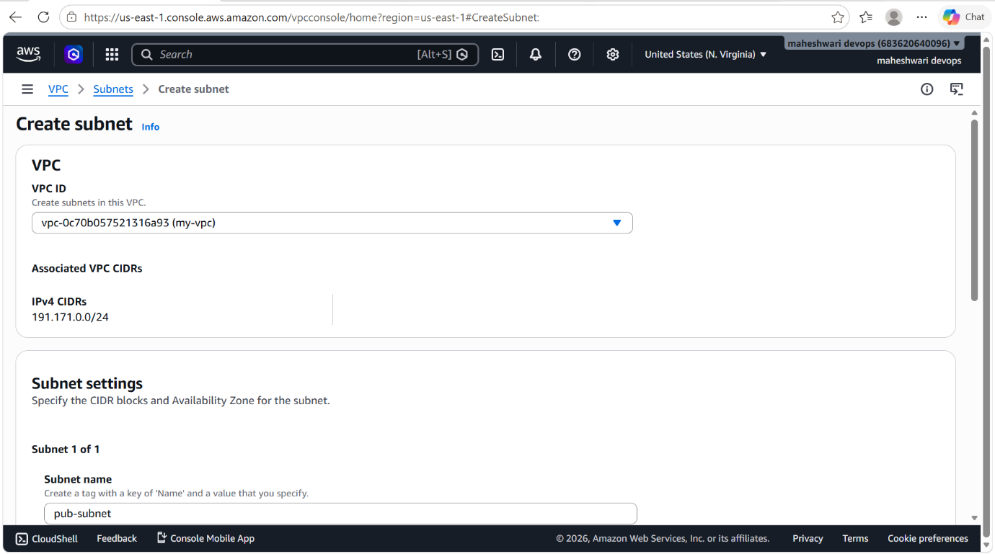

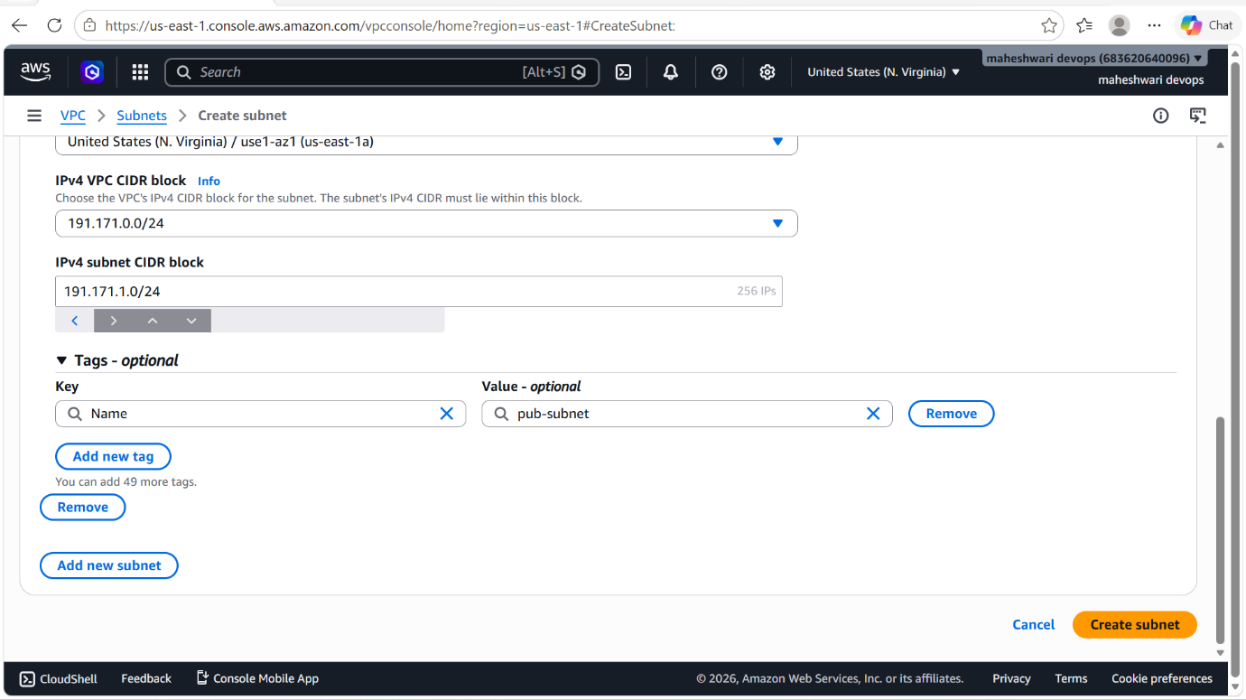

- In the navigation pane, go to subnets
- Then click on new subnet to create a private subnet.
- Fill the details in the subnet page
- Then click on create subnet with the name pri-subnet.

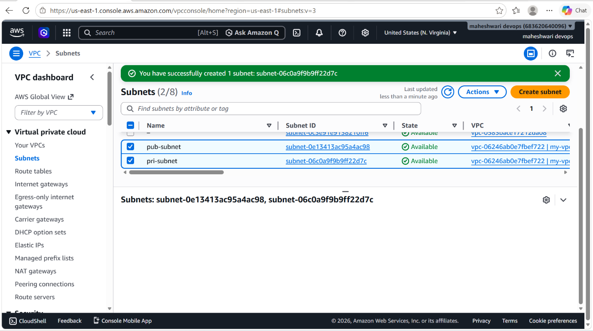

2. Enable VPC peering for cross-region.

PURPOSE: Cross-Region VPC Peering is used to establish a private network connection between VPCs located in different AWS Regions, allowing resources in those VPCs to communicate securely using private IP addresses.

OBJECTIVE: To configure cross-region VPC peering so that resources in different AWS Regions can communicate securely and directly using private IP addresses.

OUTCOME: A secure cross-region network connection is established, allowing resources in different AWS Regions to communicate directly through private IP addresses over the AWS network.

STEP BY STEP IMPLEMENTATION:

PREREQUISITES:

- Two VPCs in different AWS Regions.
- Non-overlapping CIDR blocks.
- Appropriate permissions to create VPC peering connections.

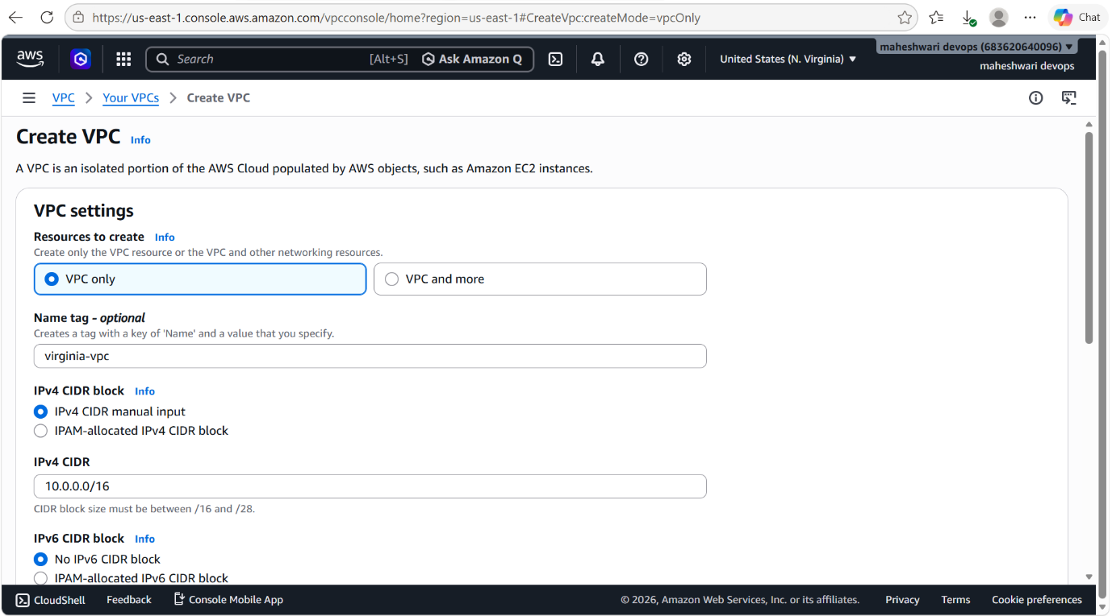

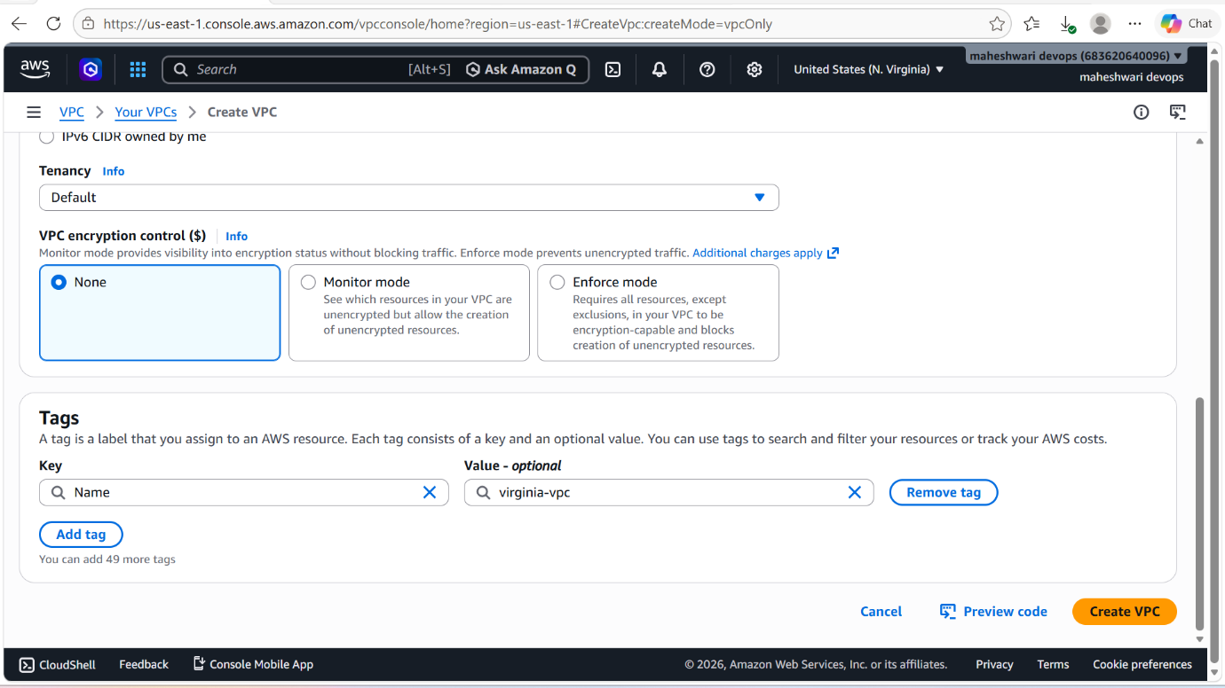

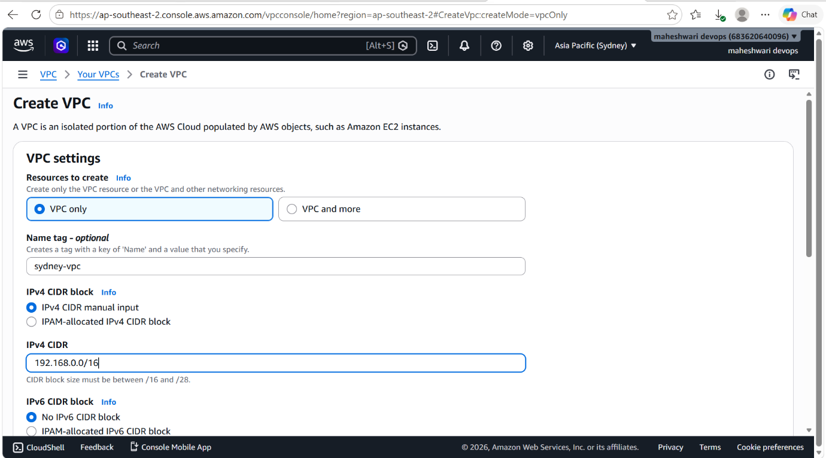

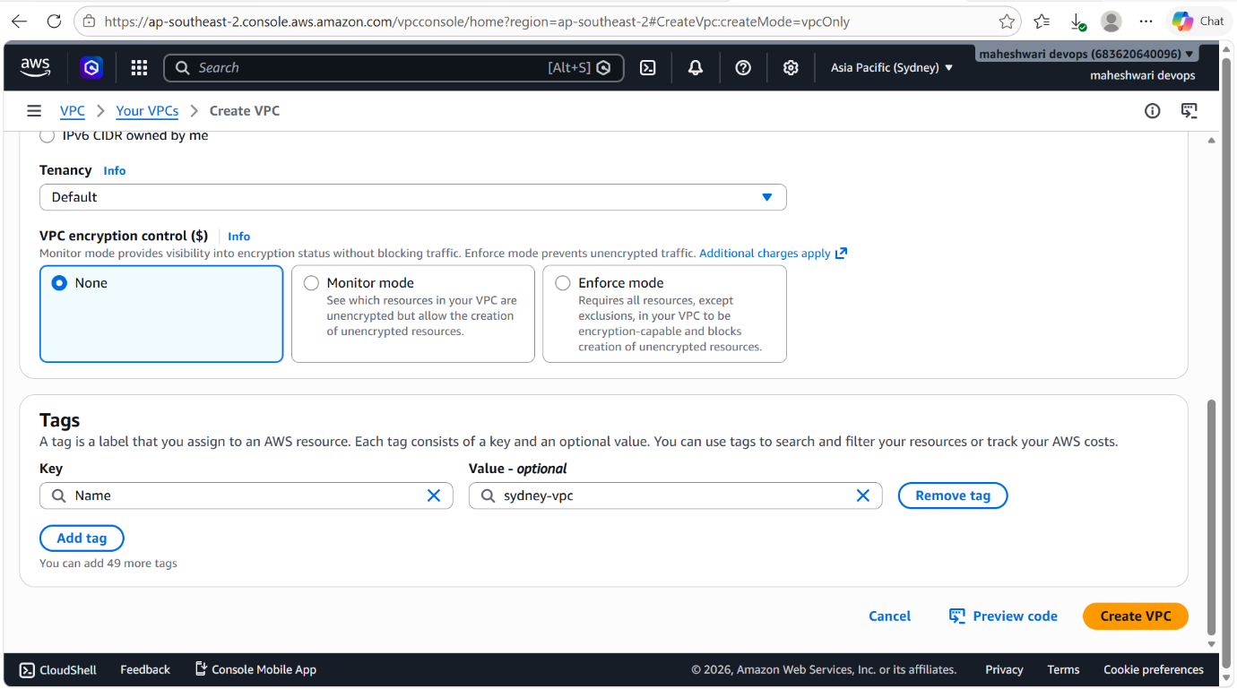

- Send the peering connection request to the remote VPC in another region.

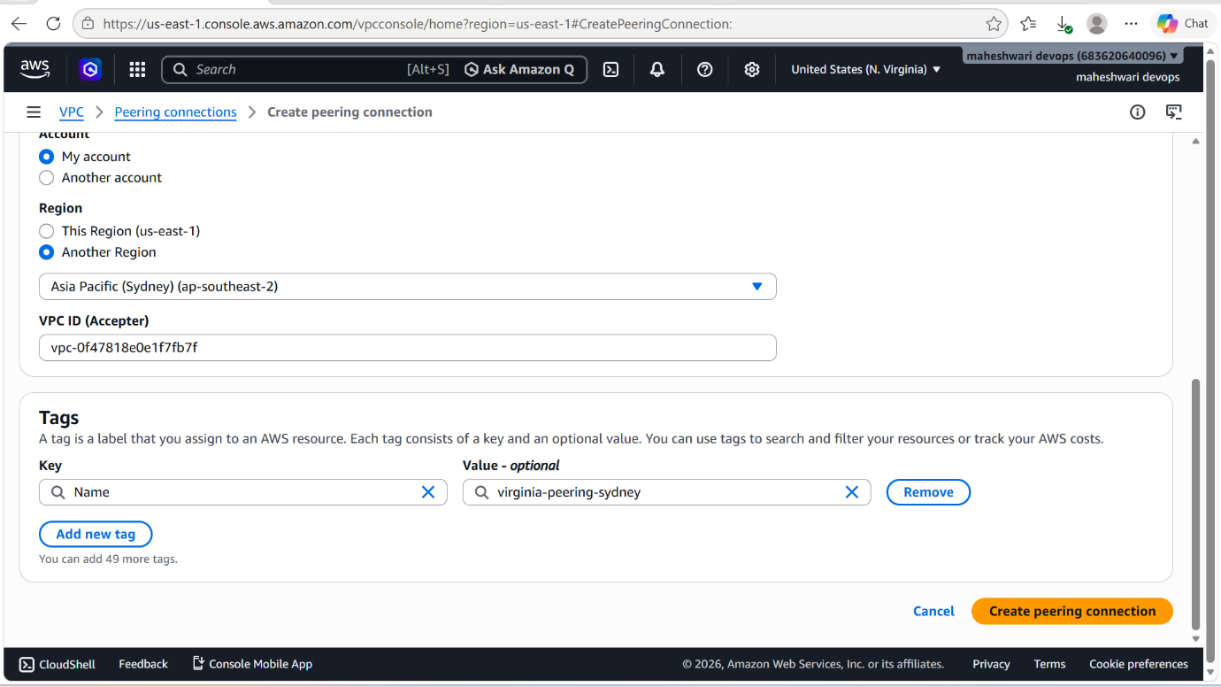

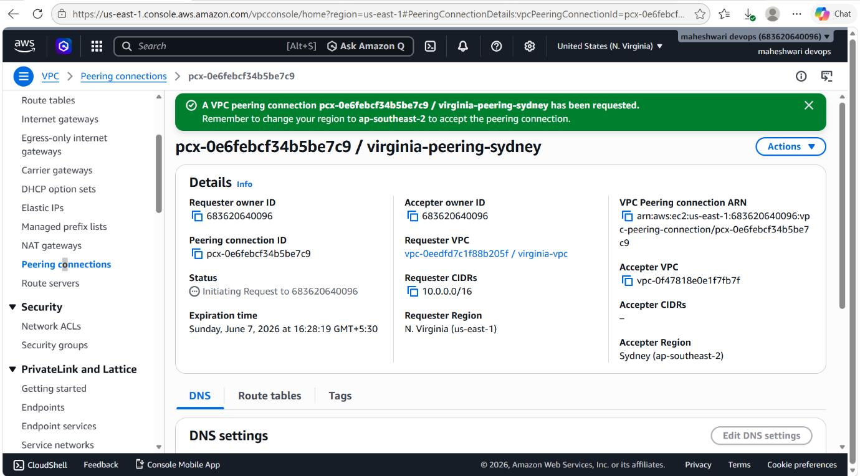

- Then check for the request of peering in the remote region.
- And there accept the request of peering.

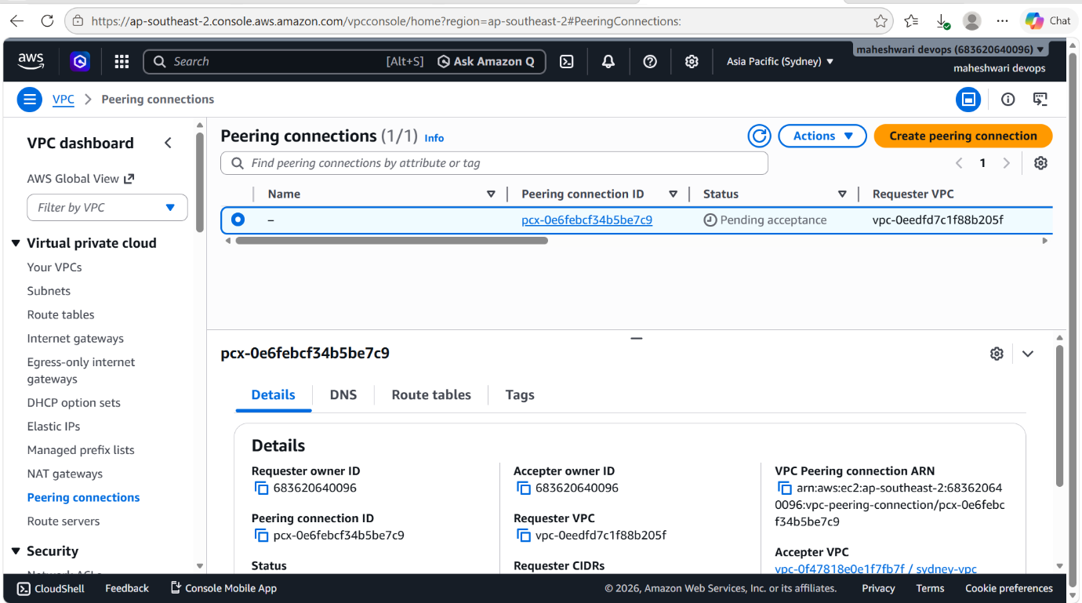

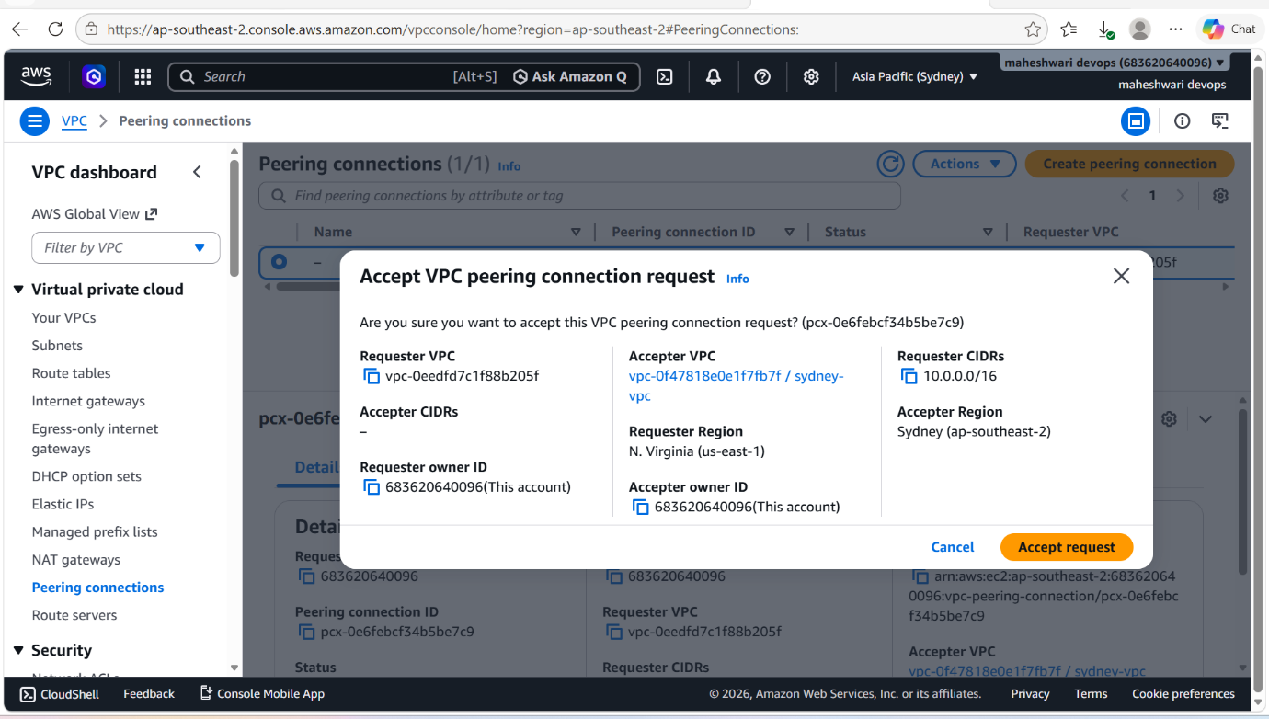

- Then launch 2 EC2 instances in each region in the same VPCs that we have created peering connection between them.

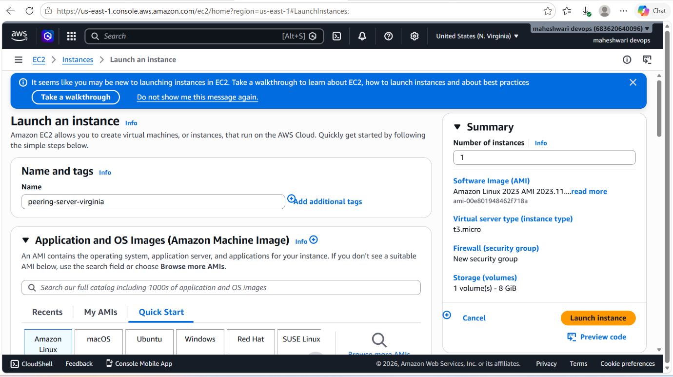

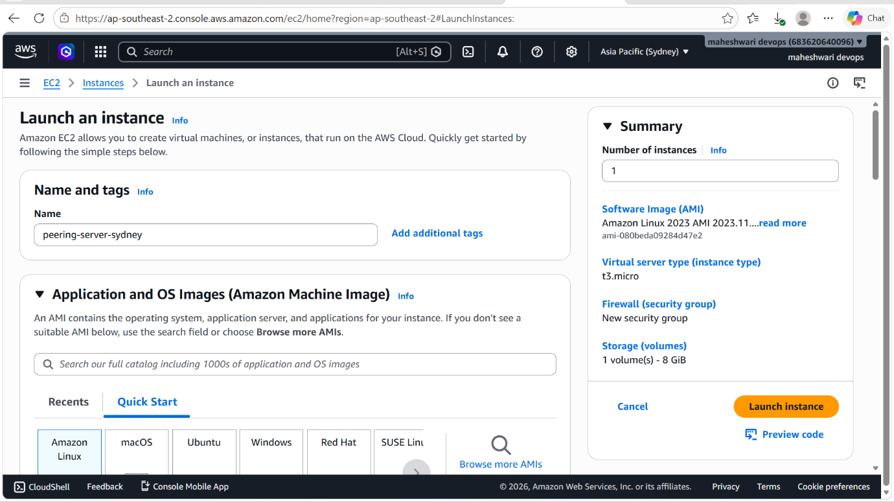

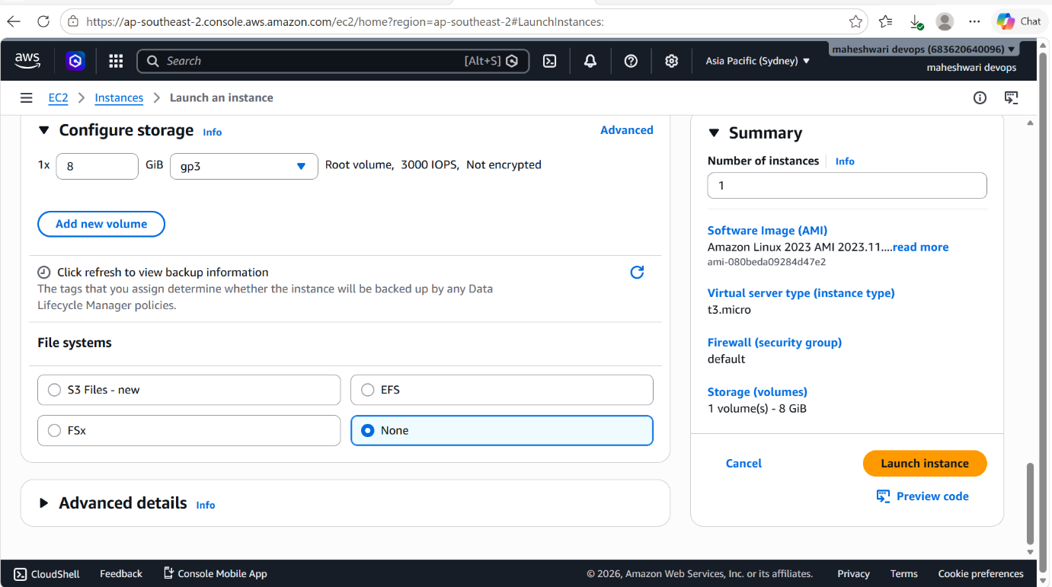

- Then login into that ec2 instance that is in requester region and successfully get that access then login into the instance that is in the remote region with the private IP.

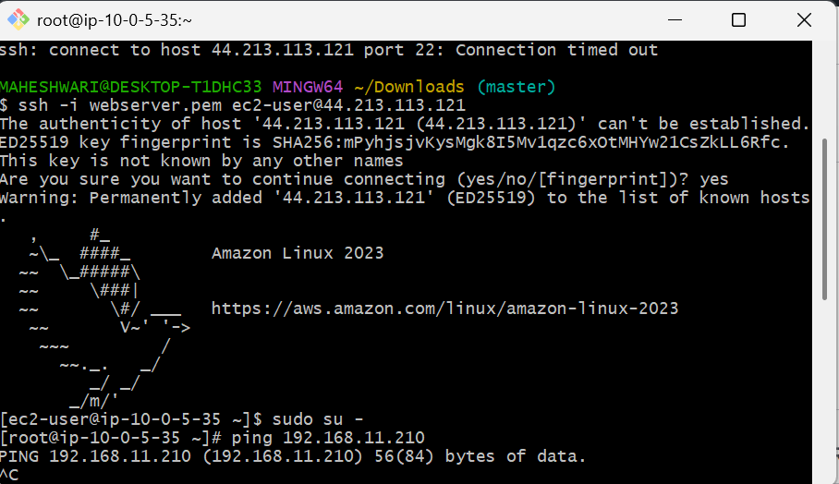

3. Enable VPC peering for cross-account.

OBJECTIVE: To establish a private network connection between VPCs that belong to different AWS accounts, allowing resources to communicate securely using private IP addresses.

OUTCOME: Cross-account VPC peering enables secure, private communication between VPCs owned by different AWS accounts using private IP addressing and AWS networking.

STEP BY STEP IMPLEMENTATION:

Step 1: Create a Peering Request (Account A)
- Sign in to Account A.
- Open the AWS VPC Console.
- Go to Peering Connections → Create Peering Connection.
- Enter:
  - Name: Cross-Account-Peering
  - Requester VPC: VPC-A
  - Account: Another account
  - AWS Account ID: (Account B ID)
  - Accepter VPC: VPC-B
- Click Create Peering Connection.
The status will show Pending Acceptance.

Step 2: Accept the Request (Account B)
- Sign in to Account B.
- Open the VPC Console.
- Navigate to Peering Connections.
- Select the pending request.
- Click Actions → Accept Request.
The status changes to Active.

Step 3: Update Route Tables
In Account A (VPC-A)
Add a route:
Destination | Target
192.168.0.0/16 | VPC Peering Connection
In Account B (VPC-B)
Add a route:
Destination | Target
10.0.0.0/16 | VPC Peering Connection

Step 4: Update Security Groups
Allow traffic from the peer VPC CIDR.
VPC-A Security Group
- Source: 192.168.0.0/16
- Protocols: As required (ICMP, SSH, HTTP, HTTPS, etc.)
VPC-B Security Group
- Source: 10.0.0.0/16
- Protocols: As required

Step 5: Test Connectivity
Launch an EC2 instance in each VPC and test communication using private IP addresses.
-> ping <private-IP>












4. Set up a VPC Transit Gateway.
PURPOSE: A VPC Transit Gateway (TGW) acts as a central hub that connects multiple VPCs and on-premises networks, simplifying network management and routing.
OBJECTIVE: To configure an AWS Transit Gateway that provides centralized, scalable and efficient connectivity between multiple VPCs and external networks.
OUTCOME: A Transit Gateway is configured as a central hub, enabling secure and scalable communication between multiple VPCs while simplifying network routing and administration.
PREREQUISITES: An AWS account with appropriate IAM permissions, two or more VPCs with non-overlapping CIDR blocks, available subnets for attachments, and configurable route tables an security settings are required before setting up a VPC Transit Gateway.
STEP BY STEP IMPLEMENTATION:
Step 1: Create a Transit Gateway
- Open the AWS VPC Console.
- In the left menu, select Transit Gateways.
- Click Create Transit Gateway.
- Enter:
  - Name: My-TGW
  - Description: Central Hub
- Keep default settings (or customize as required).
- Click Create Transit Gateway.

-> Wait until the Transit Gateway state becomes Available.

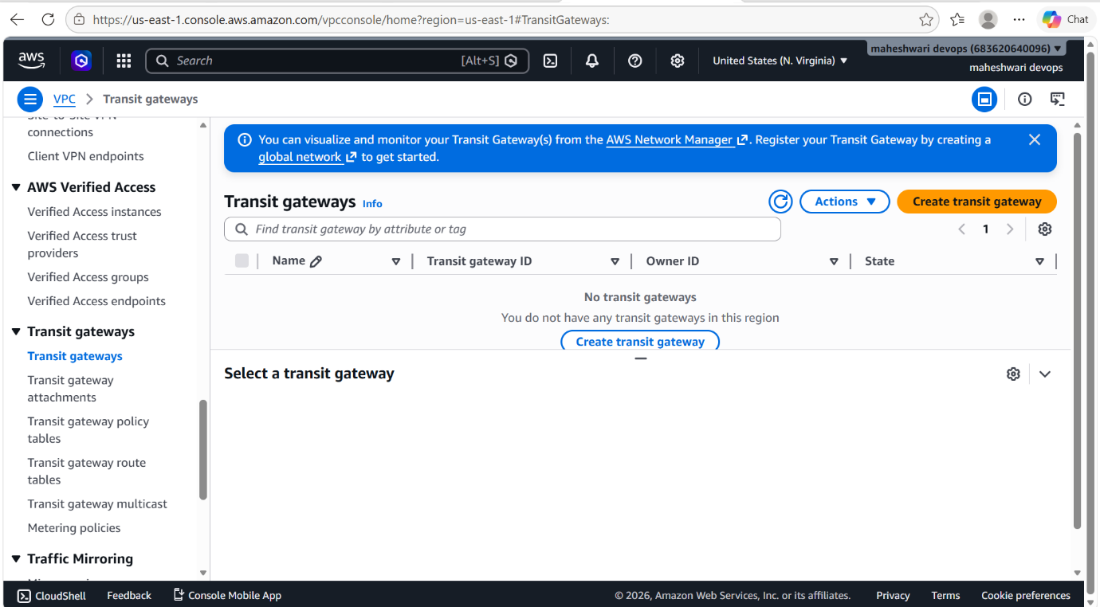

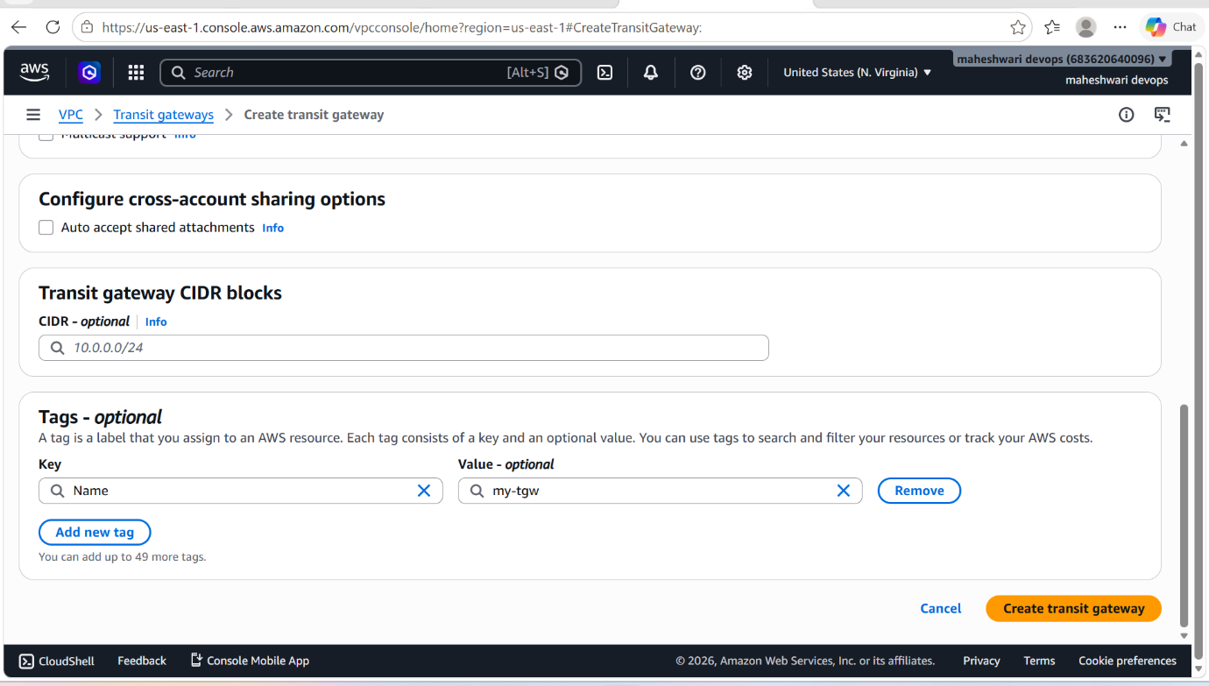

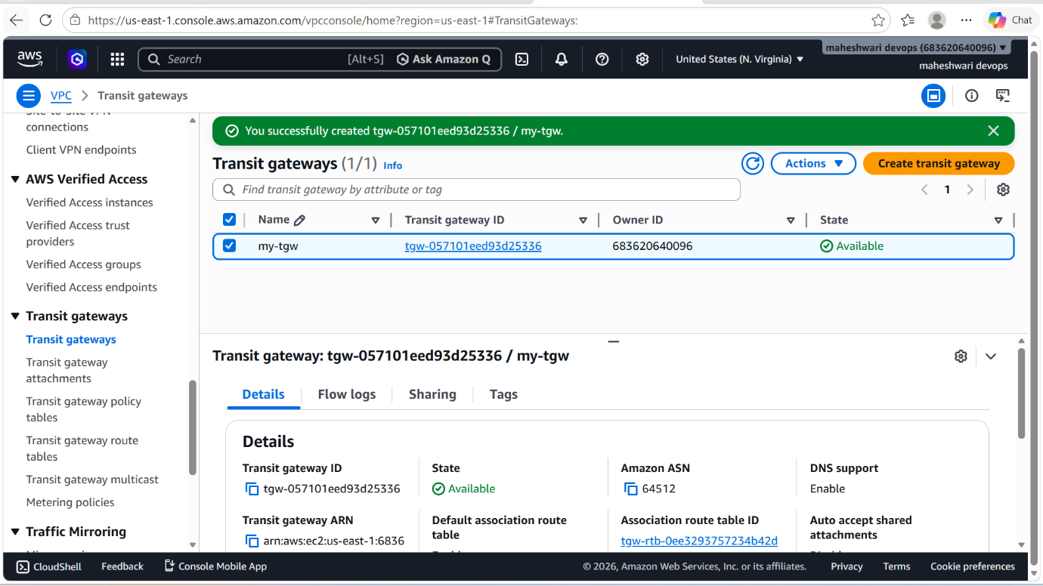
Step 2: Create a Transit Gateway Attachment for VPC-A
- Go to Transit Gateway Attachments.
- Click Create Transit Gateway Attachment.
- Select:
  - Attachment Type: VPC
  - Transit Gateway: My-TGW
  - VPC: VPC-A
- Select at least one subnet.
- Click Create Attachment.

Step 3: Create a Transit Gateway Attachment for VPC-B
Repeat the same process:
- Attachment Type: VPC
- Transit Gateway: My-TGW
- VPC: VPC-B
- Select a subnet
- Create Attachment
Wait until both attachments become Available.
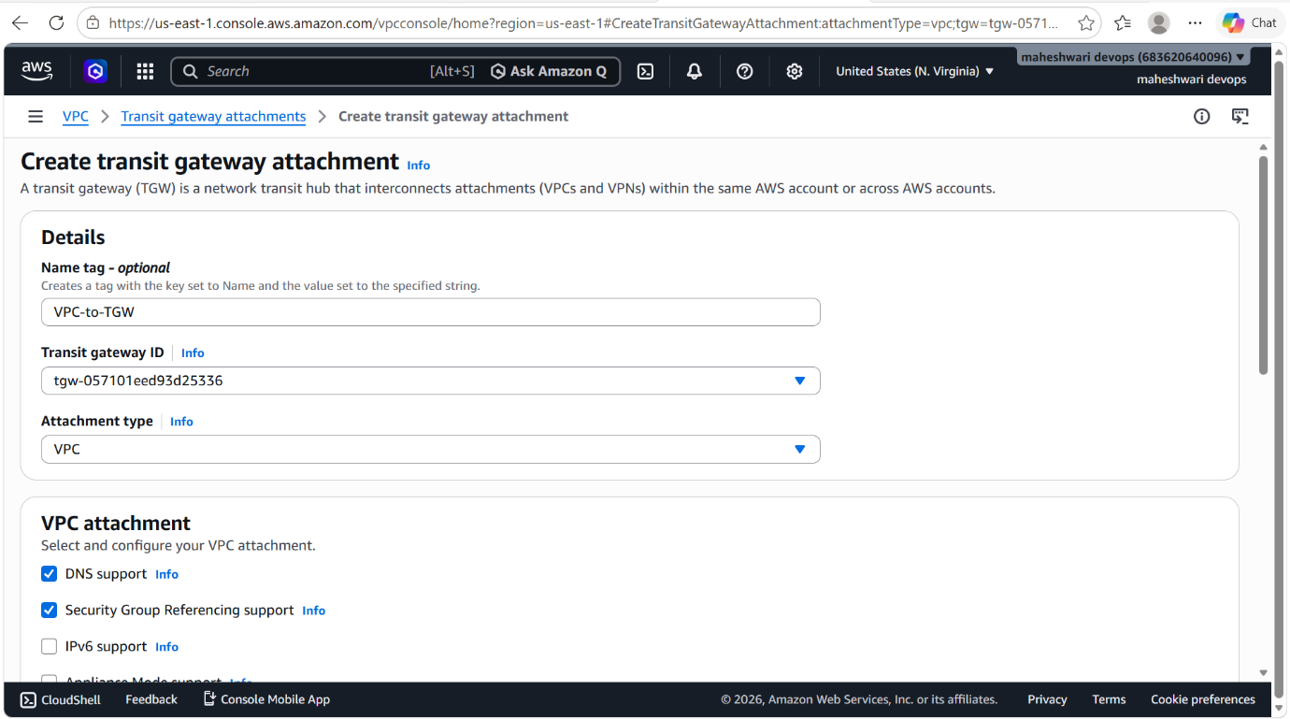

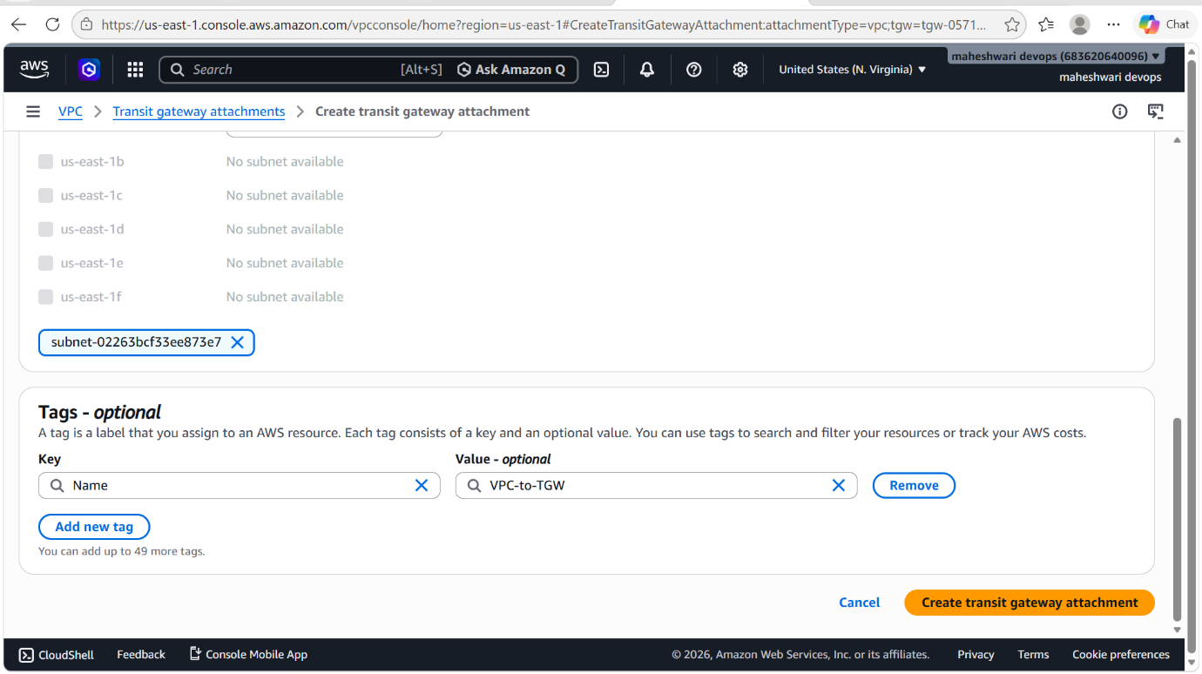

Step 4: Update Route Table in VPC-A
Navigate to the route table associated with VPC-A and add:
Destination | Target
192.168.0.0/16 | Transit Gateway
Save the route.

Step 5: Update Route Table in VPC-B
Navigate to the route table associated with VPC-B and add:
Destination | Target
10.0.0.0/16 | Transit Gateway
Save the route.

Step 6: Verify Transit Gateway Route Table
- Open Transit Gateway Route Tables.
- Select the default route table.
- Check Routes and Associations.
- Confirm both VPC attachments are associated and propagated.

Step 7: Configure Security Groups
Allow traffic from the peer VPC CIDR blocks.
VPC-A Security Group
Allow source:
192.168.0.0/16
VPC-B Security Group
Allow source:
10.0.0.0/16
Allow the required protocols (ICMP, SSH, HTTP, HTTPS, etc.).

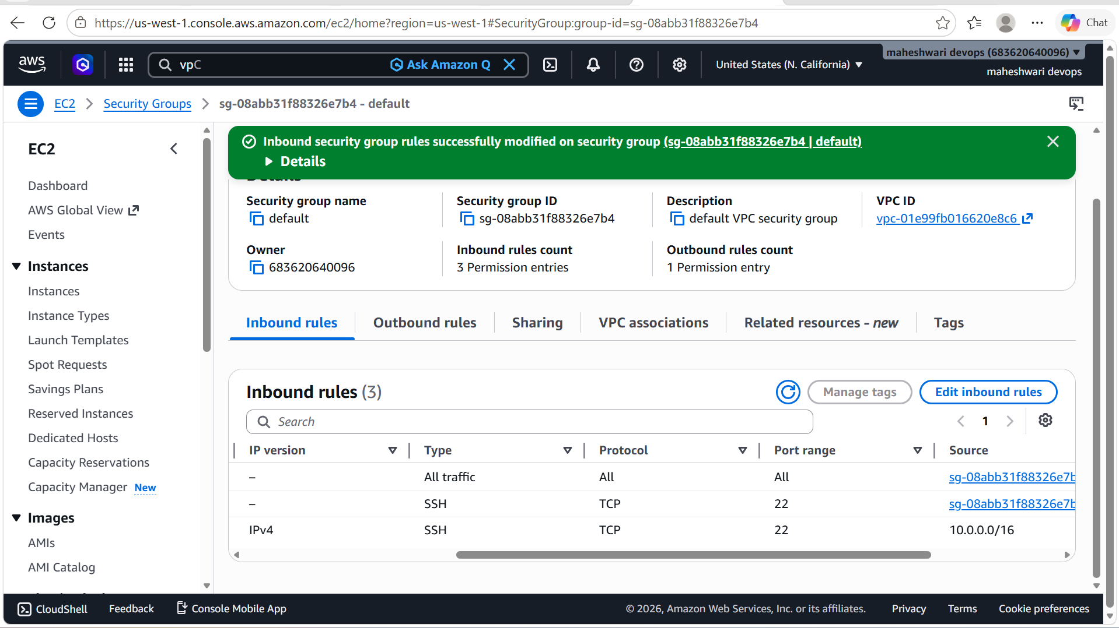

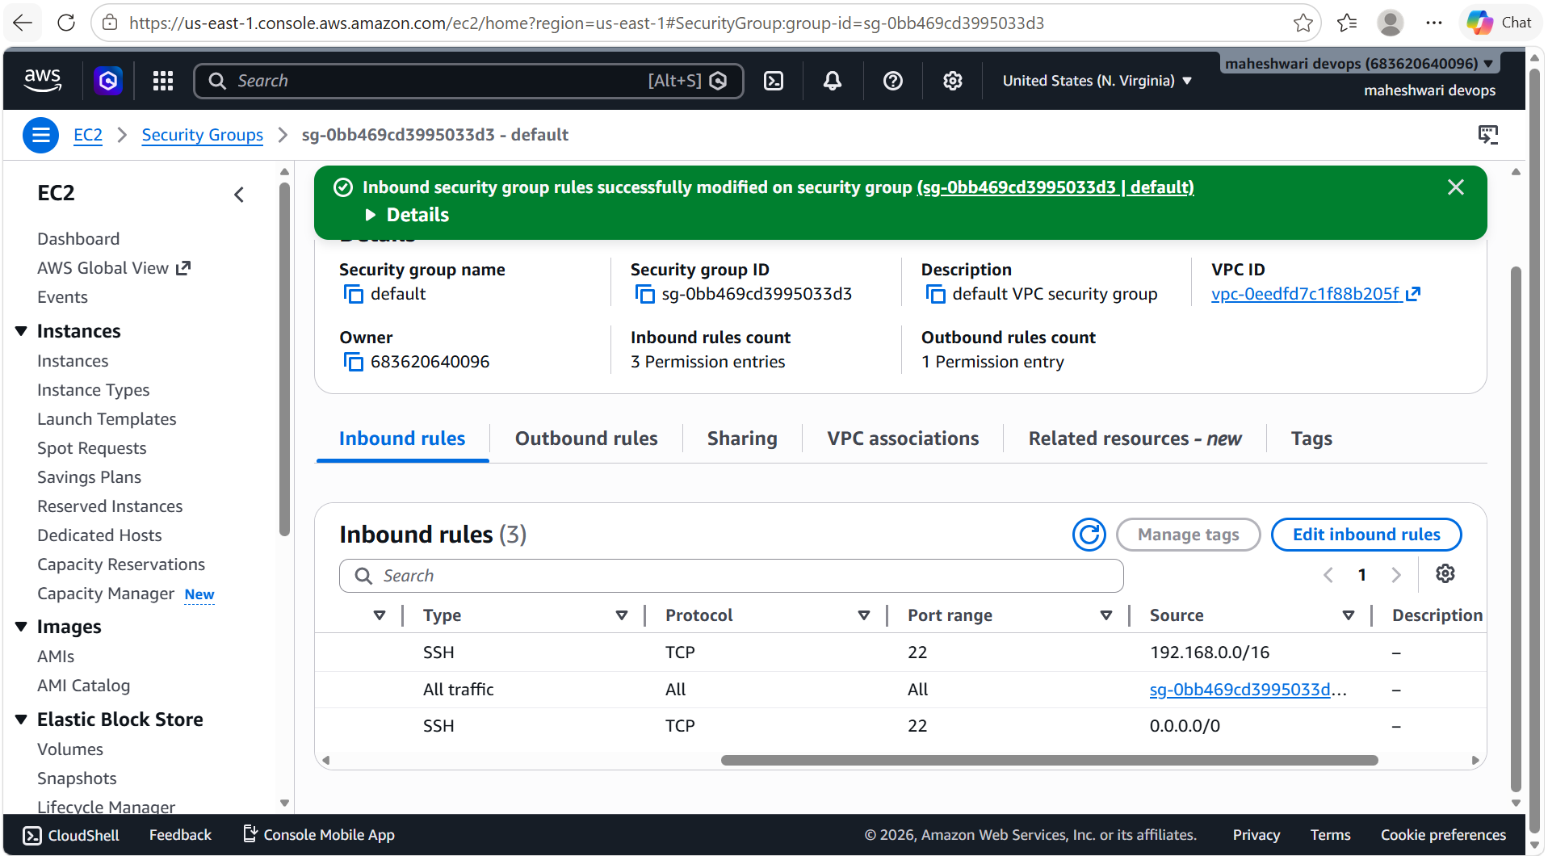

Step 8: Test Connectivity
Launch EC2 instances in both VPCs and test using private IP addresses:

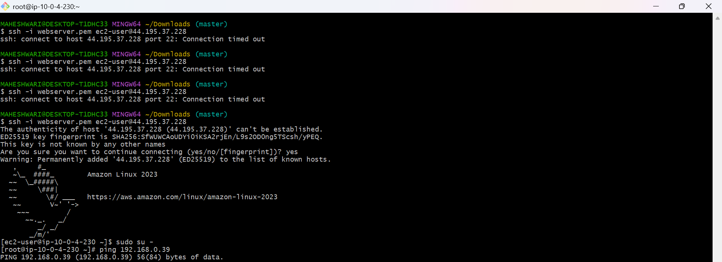

5. Set up a VPC Endpoint.
PURPOSE: To enable private connectivity between a VPC and AWS
Services without routing traffic through the internet, an internet gateway, a NAT gateway, or a VPN connection.

OBJECTIVE: To configure a VPC Endpoint that allows resources within a VPC to securely access AWS services using the AWS private network.
PREREQUISITES:
- An AWS account with appropriate permissions.
- An existing VPC.
- At least one subnet in the VPC.
- Route tables available for modification.
- A target AWS service (ex: Amazon S3 or DynamoDB).

TYPES OF VPC ENDPOINTS:

1.Gateway Endpoint:
Supported services:
- Amazon S3
- Amazon DynamoDB
2. Interface Endpoint:
Supported services:
- Amazon EC2 APIs
- AWS Systems Manager
- Amazon CloudWatch
- Many other AWS services.

OUTCOME: A VPC Endpoint provides secure and private access from a VPC to AWS Services such as Amazon S3 and DynamoDB without traversing the public internet.

STEP BY STEP IMPLEMENTATION:

Example: Create an S3 Gateway Endpoint
Step 1: Open the VPC Console
- Sign in to AWS.
- Navigate to VPC Dashboard.
- Select Endpoints.
- Click Create Endpoint.

Step 2: Select Service
- Service Category:
  - AWS Services
- Service Name: com.amazonaws.<region>.s3
Step 3: Select VPC
Choose:
- Your VPC (e.g., My-VPC)

Step 4: Select Route Tables
Choose the route tables associated with the subnets that require S3 access.
AWS automatically adds routes to the selected route tables.

Step 5: Configure Policy
Choose:
Full Access

Step 6: Create Endpoint
Click Create Endpoint.
The endpoint state should become Available.

Verify Configuration
From an EC2 instance inside the VPC:
-> aws s3 ls

